**A Comprehensive Analysis of Financial Performance; Insight from a Leading Banks**

**Introduction**

The banking industry world-wide is being transformed. In this project we are trying to analysis the bank related data and able to extract some insights from the data using business intelligence tools. To extract the insight from the data and put the data in the form of visualization, dashboards and story we employed tableau tool.

It demonstrates the interrelationship between the income statement and balance sheet and describes the risk and return trade-off underlying management decision.

Problems Definitions & Design Thinking

**Empathy Map**

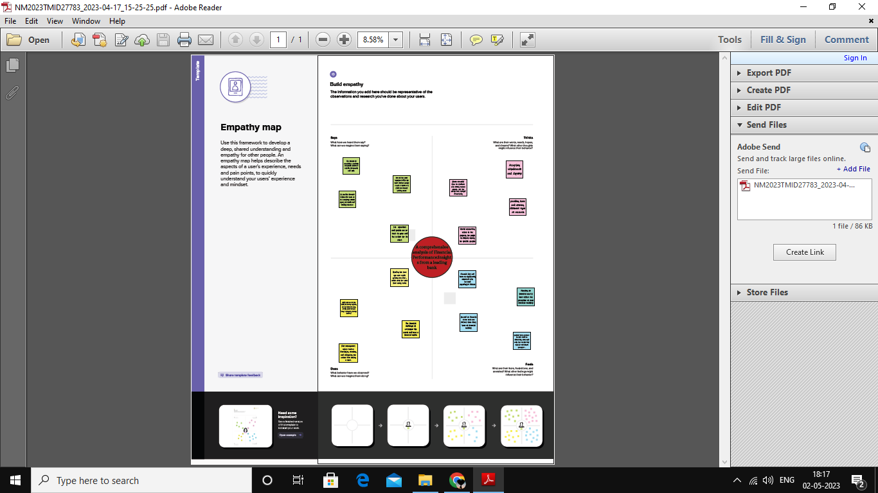

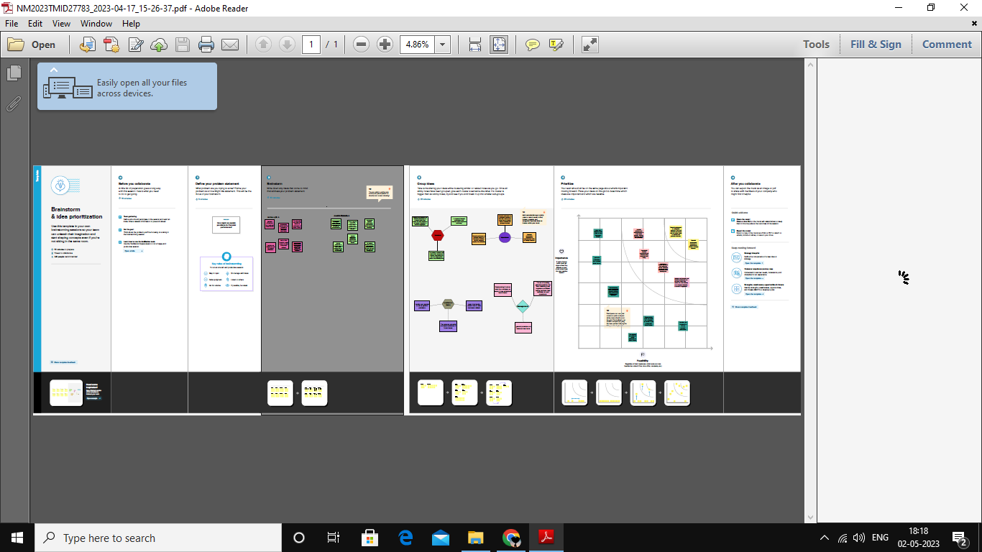

**Result**

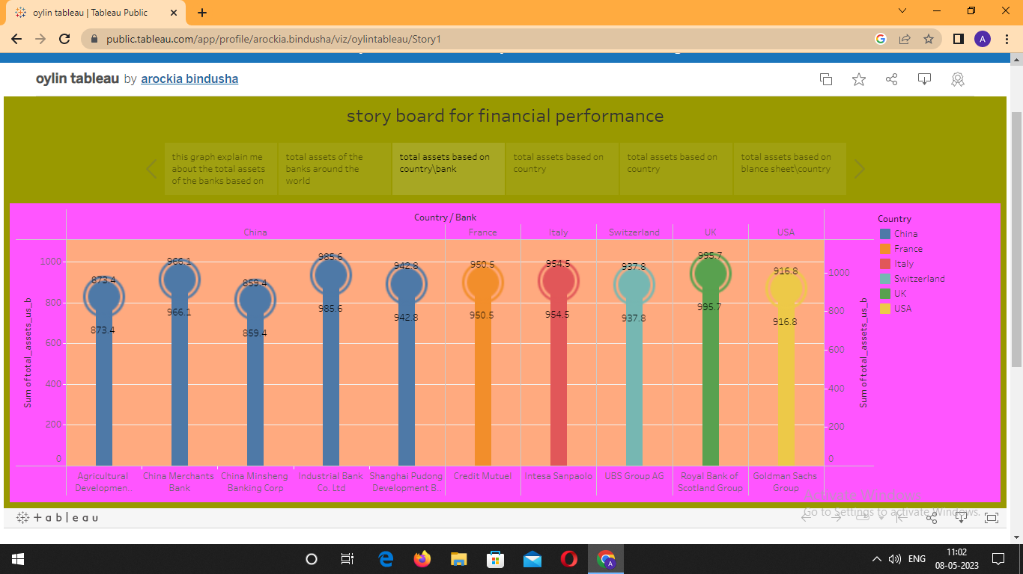

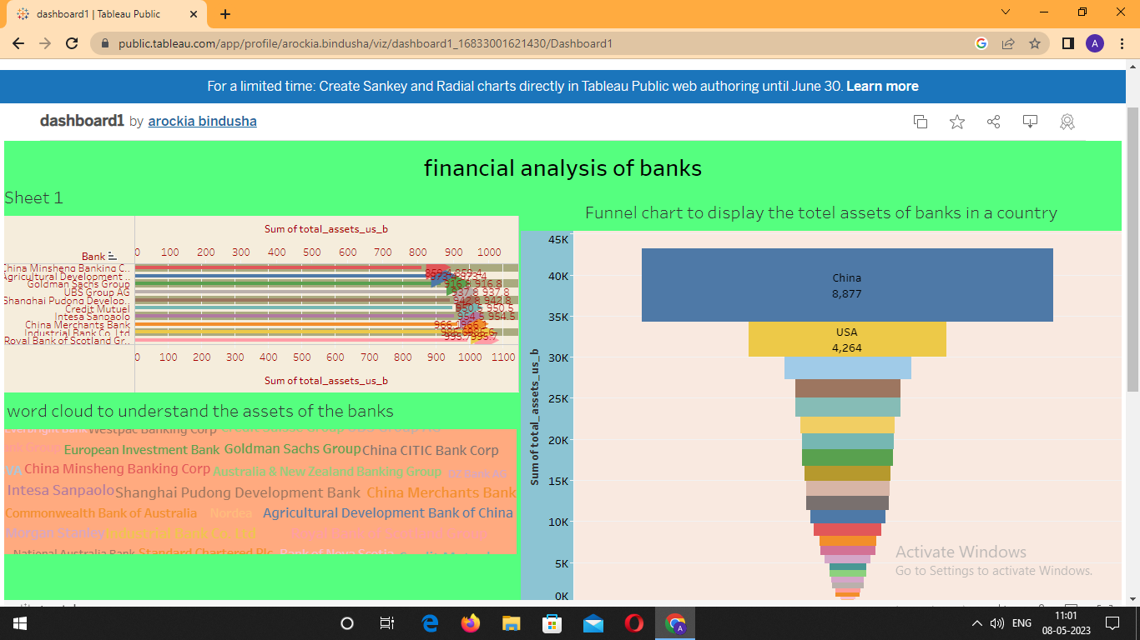

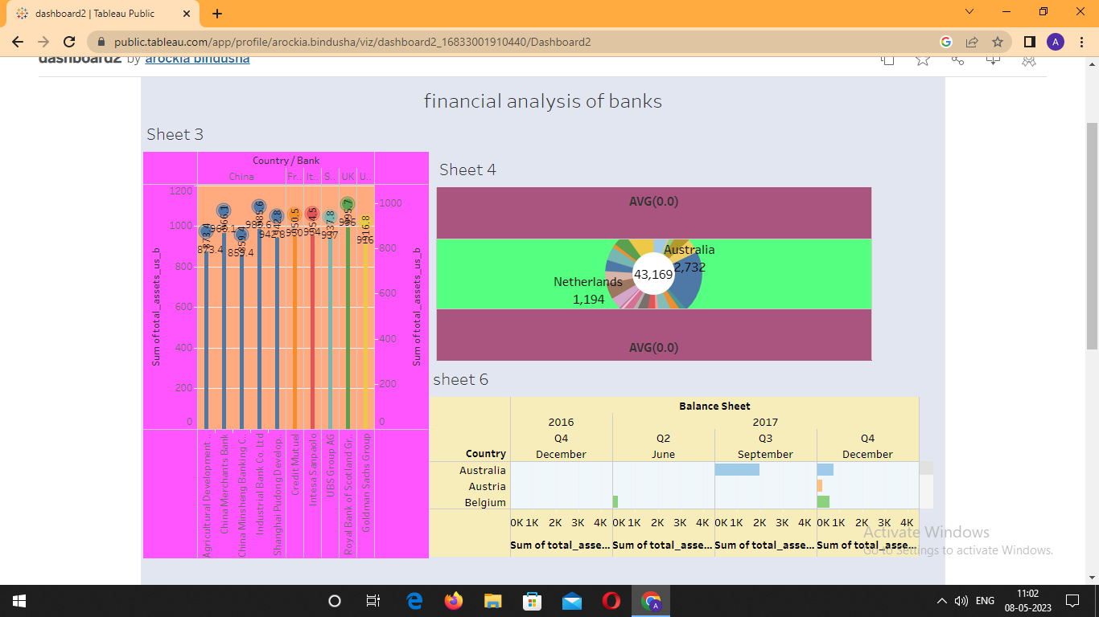

**Advantages & Disadvantages**

Financial statement reveal how much a company earns per year in sales. The sales may fluctuate, but financial planner should be able to identify a pattern over year of sales figures.

Another advantage of using financial statement for future planning and decision making is that they show the company’s budgets. The budgets reveal how much wiggle room the company has to spend on launching product, developing marketing campaigns or expanding the current office size.

One advantage of using financial statement for decision making is that the data and figures are based on the market at that given time. Depending on the market, it may change quickly, so executives should not assume that the number from a previous financial statement will remain the same or increase.

A single financial statement only show hoe a company is doing at one show whether the company is doing better or worse than the year before.

**Applications**

Analytic in banking and financial services can help in the efficient management of IT system and service level agreements. These systems provide the shareholders with all the performance related indicators of the workforce. This information helps decision-makers in evaluating the vendors’ effectiveness and avoids any unnecessary costs. Using BI tools to predict the cash required at each of its ATMs across the country and combining this with route-optimization techniques.

**Conclusion**

This session gives the information about bank financial statements and provides a traditional, ratio-based procedure for analyzing bank financial performance using historical data. It demonstrates the interrelationship between the income statement and balance sheet and describes the risk and return trade-off underlying managenment decision. Data are provided that compare the performance characteristic of small banks versus large banks and differentiate between high and low performers.

**Future scope**

Probability analysis is summarized as evaluation different process like costing, pricing, distribution, etc. it is evaluating that determines the suitability and performance of a business function or activity. In addition, activity analysis is focused on determining whether the activity will achieve its goals.

Emeritus India offers some of the best finance courses that equip candidates with skills and in-depth knowledge of different finance concept. We have many intensive finance programmes that help candidates gain a strong foundation in financial analysis.

**Appendix**

<div class='tableauPlaceholder' id='viz1683561160057' style='position: relative'><noscript><a href='#'><img alt='financial analysis of banks ' src='https:&#47;&#47;[public.tableau.com](http://public.tableau.com/)&#47;static&#47;images&#47;da&#47;dashboard1_16833001621430&#47;Dashboard1&#47;1_rss.png' style='border: none' /></a></noscript><object class='tableauViz'  style='display:none;'><param name='host_url' value='https%3A%2F%[2Fpublic.tableau.com](http://2fpublic.tableau.com/)%2F' /> <param name='embed_code_version' value='3' /> <param name='site_root' value='' /><param name='name' value='dashboard1_16833001621430&#47;Dashboard1' /><param name='tabs' value='no' /><param name='toolbar' value='yes' /><param name='static_image' value='https:&#47;&#47;[public.tableau.com](http://public.tableau.com/)&#47;static&#47;images&#47;da&#47;dashboard1_16833001621430&#47;Dashboard1&#47;1.png' /> <param name='animate_transition' value='yes' /><param name='display_static_image' value='yes' /><param name='display_spinner' value='yes' /><param name='display_overlay' value='yes' /><param name='display_count' value='yes' /><param name='language' value='en-US' /></object></div>                <script type='text/javascript'>                    var divElement = document.getElementById('viz1683561160057');                    var vizElement = divElement.getElementsByTagName('object')[0];                    if ( divElement.offsetWidth > 800 ) { vizElement.style.width='100%';vizElement.style.height=(divElement.offsetWidth*0.75)+'px';} else if ( divElement.offsetWidth > 500 ) { vizElement.style.width='100%';vizElement.style.height=(divElement.offsetWidth*0.75)+'px';} else { vizElement.style.width='100%';vizElement.style.height='977px';}                     var scriptElement = document.createElement('script');                    scriptElement.src = '<https://public.tableau.com/javascripts/api/viz_v1.js>';                    vizElement.parentNode.insertBefore(scriptElement, vizElement);                </script>

<div class='tableauPlaceholder' id='viz1683561047373' style='position: relative'><noscript><a href='#'><img alt='financial analysis of banks ' src='https:&#47;&#47;[public.tableau.com](http://public.tableau.com/)&#47;static&#47;images&#47;da&#47;dashboard2_16833001910440&#47;Dashboard2&#47;1_rss.png' style='border: none' /></a></noscript><object class='tableauViz'  style='display:none;'><param name='host_url' value='https%3A%2F%[2Fpublic.tableau.com](http://2fpublic.tableau.com/)%2F' /> <param name='embed_code_version' value='3' /> <param name='site_root' value='' /><param name='name' value='dashboard2_16833001910440&#47;Dashboard2' /><param name='tabs' value='no' /><param name='toolbar' value='yes' /><param name='static_image' value='https:&#47;&#47;[public.tableau.com](http://public.tableau.com/)&#47;static&#47;images&#47;da&#47;dashboard2_16833001910440&#47;Dashboard2&#47;1.png' /> <param name='animate_transition' value='yes' /><param name='display_static_image' value='yes' /><param name='display_spinner' value='yes' /><param name='display_overlay' value='yes' /><param name='display_count' value='yes' /><param name='language' value='en-US' /></object></div>                <script type='text/javascript'>                    var divElement = document.getElementById('viz1683561047373');                    var vizElement = divElement.getElementsByTagName('object')[0];                    if ( divElement.offsetWidth > 800 ) { vizElement.style.width='1000px';vizElement.style.height='827px';} else if ( divElement.offsetWidth > 500 ) { vizElement.style.width='1000px';vizElement.style.height='827px';} else { vizElement.style.width='100%';vizElement.style.height='927px';}                     var scriptElement = document.createElement('script');                    scriptElement.src = '<https://public.tableau.com/javascripts/api/viz_v1.js>';                    vizElement.parentNode.insertBefore(scriptElem<div class='tableauPlaceholder' id='viz1683561160057' style='position: relative'><noscript><a href='#'><img alt='financial analysis of banks ' src='https:&#47;&#47;[public.tableau.com](http://public.tableau.com/)&#47;static&#47;images&#47;da&#47;dashboard1_16833001621430&#47;Dashboard1&#47;1_rss.png' style='border: none' /></a></noscript><object class='tableauViz'  style='display:none;'><param name='host_url' value='https%3A%2F%[2Fpublic.tableau.com](http://2fpublic.tableau.com/)%2F' /> <param name='embed_code_version' value='3' /> <param name='site_root' value='' /><param name='name' value='dashboard1_16833001621430&#47;Dashboard1' /><param name='tabs' value='no' /><param name='toolbar' value='yes' /><param name='static_image' value='https:&#47;&#47;[public.tableau.com](http://public.tableau.com/)&#47;static&#47;images&#47;da&#47;dashboard1_16833001621430&#47;Dashboard1&#47;1.png' /> <param name='animate_transition' value='yes' /><param name='display_static_image' value='yes' /><param name='display_spinner' value='yes' /><param name='display_overlay' value='yes' /><param name='display_count' value='yes' /><param name='language' value='en-US' /></object></div>                <script type='text/javascript'>                    var divElement = document.getElementById('viz1683561160057');                    var vizElement = divElement.getElementsByTagName('object')[0];                    if ( divElement.offsetWidth > 800 ) { vizElement.style.width='100%';vizElement.style.height=(divElement.offsetWidth*0.75)+'px';} else if ( divElement.offsetWidth > 500 ) { vizElement.style.width='100%';vizElement.style.height=(divElement.offsetWidth*0.75)+'px';} else { vizElement.style.width='100%';vizElement.style.height='977px';}                     var scriptElement = document.createElement('script');                    scriptElement.src = '<https://public.tableau.com/javascripts/api/viz_v1.js>';                    vizElement.parentNode.insertBefore(scriptElement, vizElement);                </script>

ent, vizElement);                </script>